

**Subject:** Object Oriented Software Engineering

**Submitted to:** Sir Jawad Khan

**Group Members:**

1. Hozefa Hassan Rizvi **(FA20-BSE-019)**

2. Najeeb Said **(FA20-BSE-023)**

3. Asad Waseem **(FA20-BSE-153)**

4. Muhammad Kashan**(FA20-BSE-008)**

5. Wajid Akbar **(FA20-BSE-014)**

**DEPARTMANT**

**COMPUTER SCIENCES**

**COMSATS University of information technology**

**Abbottabad**

**25 April, 2022**

INVENTORY MANAGEMENT SYSTEM

System Sequence Diagram

Following are the system sequence diagram for use cases:  
**LOGIN :**

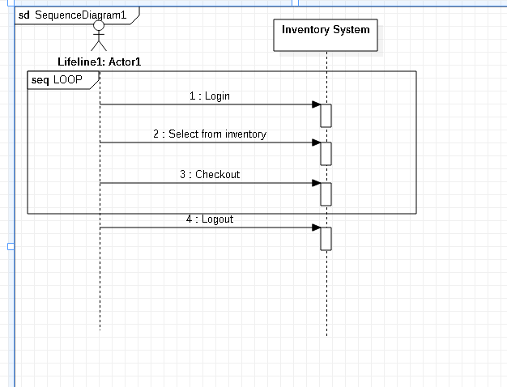

# **Register:**

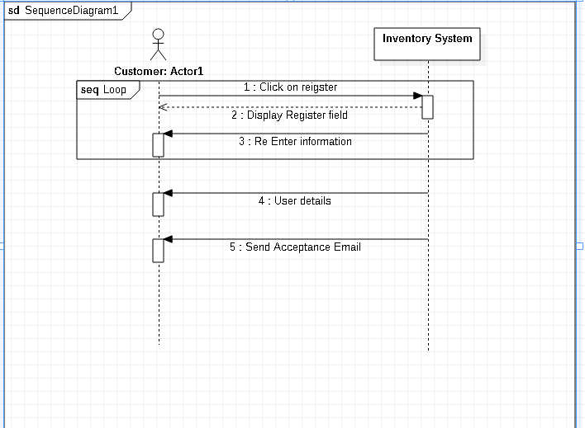

**Accounts:**

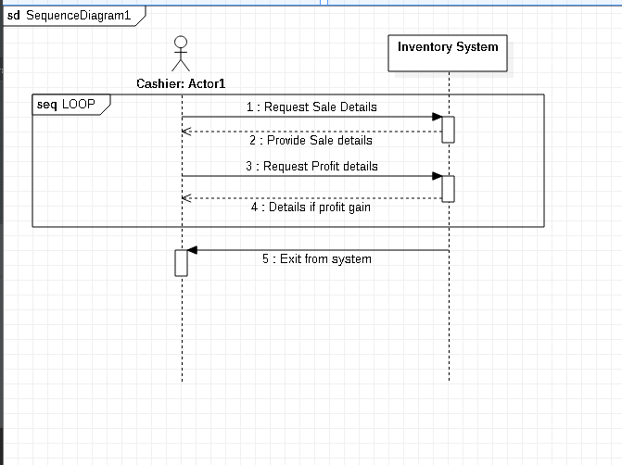

**Sale Process:**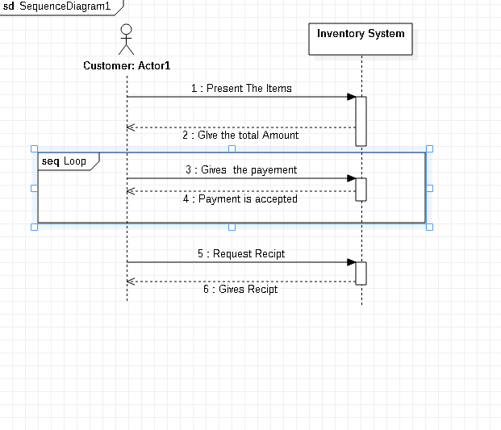

**Available Stock:**

